Application Testing

* This is the document for the testing of the mobile applications.
* The functionality of the mobile apps is mostly responsible for generating UI elements for navigating around the software (which is found on the Internet) and to ensure that the content adapts well to various display sizes, resolutions, aspect ratios and operating system versions.

**Screenshots (manual testing):**

Android:

Android 9.0 Pie on Pixel 2 XL:

Portrait:

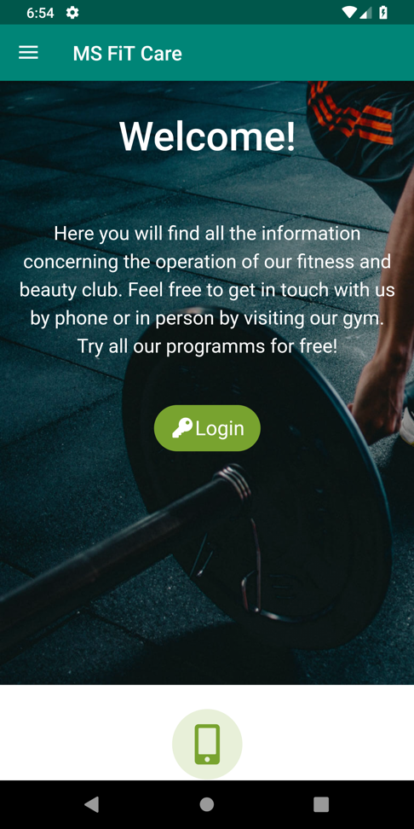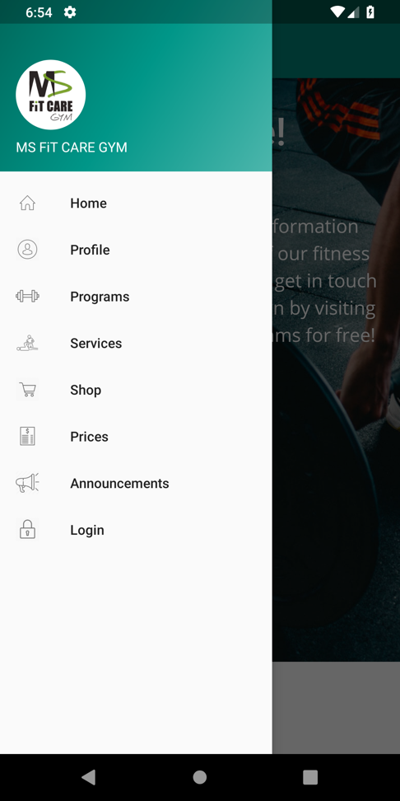

Landscape:



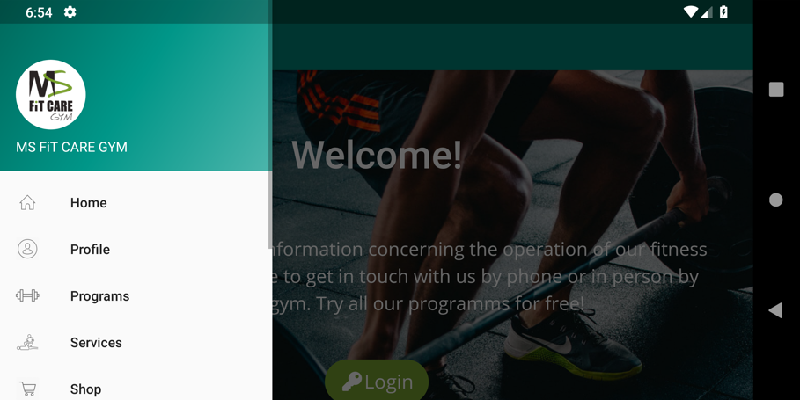

Android 7.0 Nougat on Nexus 5X:

Portrait:

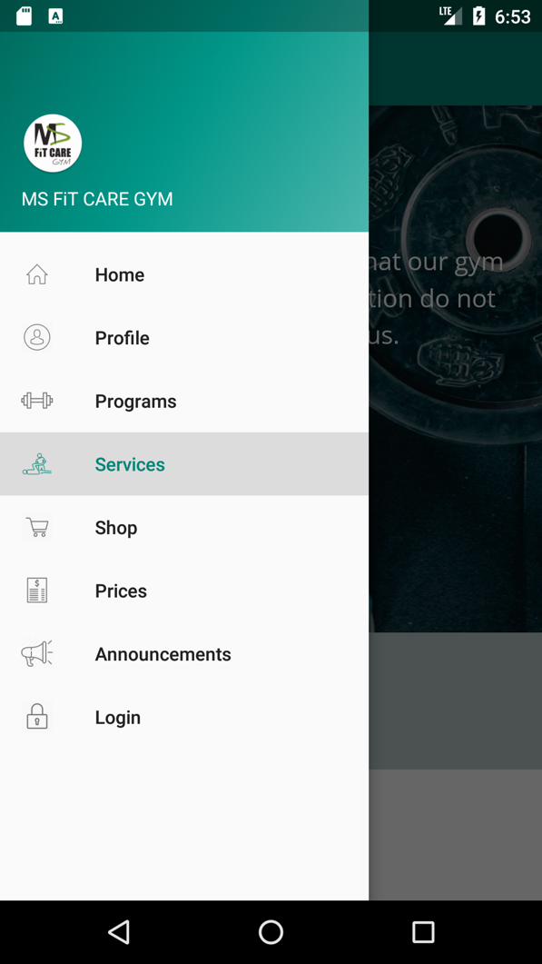

Landscape:

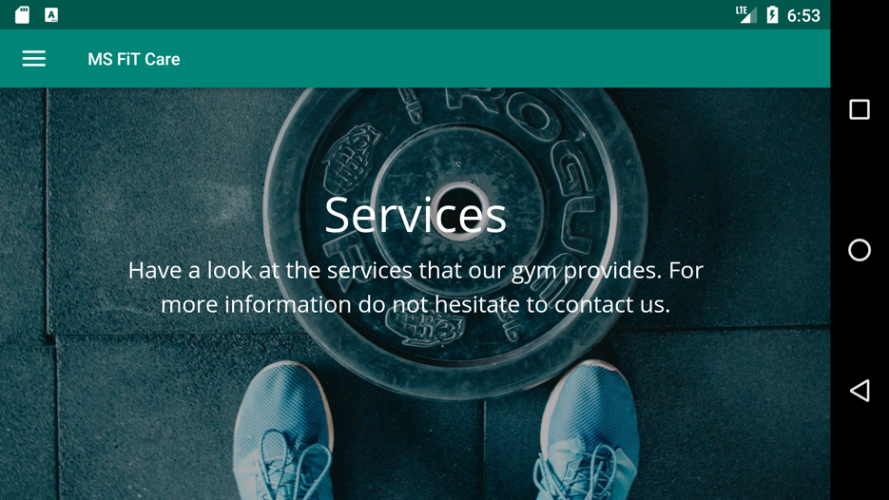

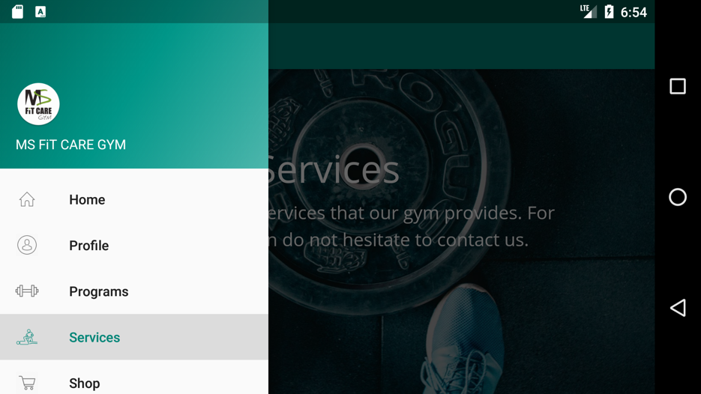

Android 9.0 Pie on Pixel C tablet:

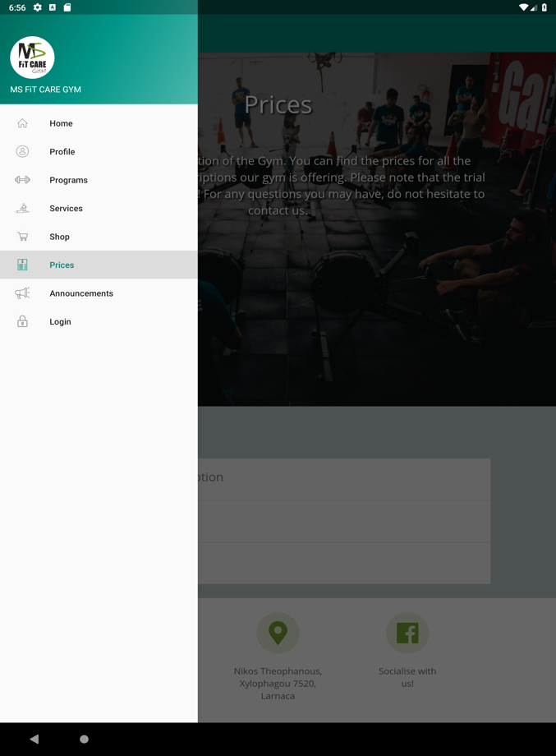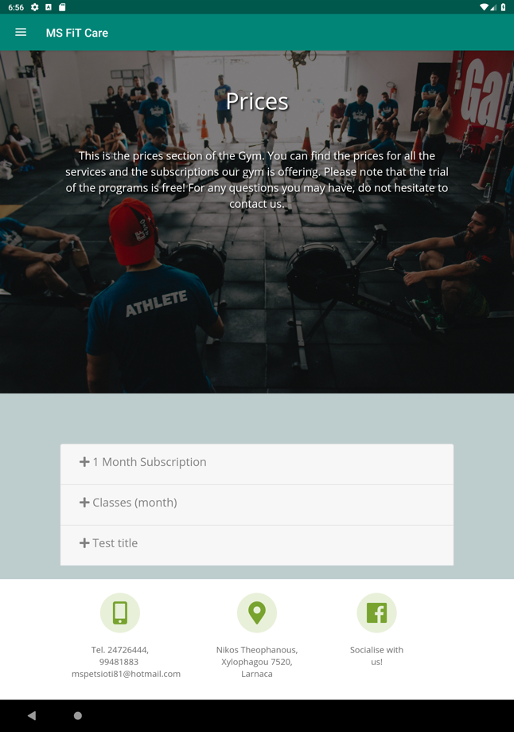Portrait:

Landscape:

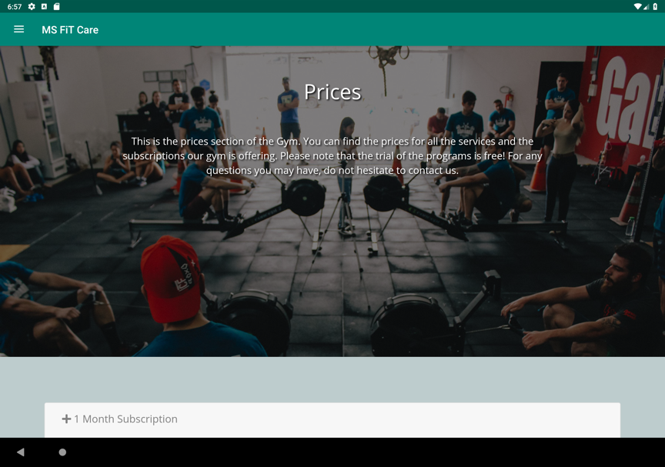

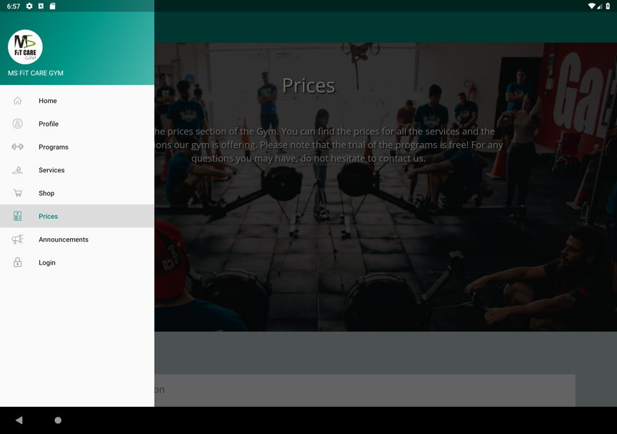

iOS:

iPhone 8 on iOS 12.2

Portrait:

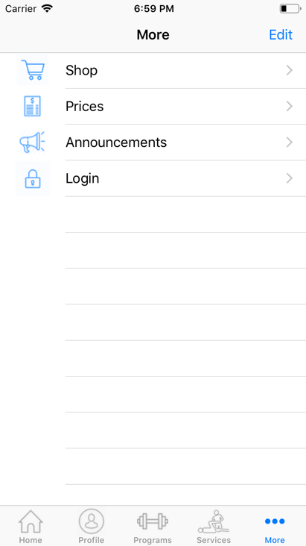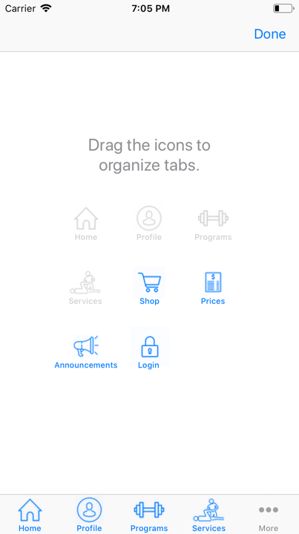

Landscape:



iPhone Xs on iOS 12.2

Portrait:



Landscape:



iPad (6th Generation) on iOS 12.2

Portrait:



Landscape:



* The applications were tested on many other devices, both physical and in a software simulator
* All UI elements are dynamic, so they can be rendered correctly on all resolutions and aspect ratios, as shown above